MSME Payables Compliance Tracker
Section 43B(h) · MSME Form 1 · Section 16 interest — AICA Level 2 Capstone Project
Item | Details
Programme | AICA Level 2 – Capstone Project
Submitted by | Maanav Goenka
Membership number | 262344
Date | October 2026
Project type | Working application (Python + Streamlit) with source code, samples and tests

1. The problem
Companies buying from Micro and Small enterprises (MSEs) must pay within the agreed credit period (at most 45 days, or 15 days with no written agreement) under the MSMED Act, 2006. A late payment has three separate consequences to track:
- Section 43B(h), Income Tax: unpaid, overdue bills at year end are disallowed until paid.
- MSME Form 1: half-yearly return of dues unpaid beyond 45 days, with reasons.
- Section 16 interest: compound interest, monthly rests, at 3 × RBI Bank Rate.
Most teams track this by hand in Excel from ERP exports and vendor statements; it is slow, person-dependent and error-prone. This tool does it repeatably: upload the data, and get due dates, exposure, the 43B(h) workings, Form 1 and the interest statement as Excel files.

2. Features
Feature | What it does
Company workspaces | Pick a company; each has its own vendor master (category, PAN, Udyam, agreed credit days). Nothing is company-specific.
Flexible input | Standard templates, vendor statements, or any software export (Excel / CSV / text PDF) – layout detected, rows classified as bills or payments, with a review step.
Opening balances | Bill-wise or party-wise dues already unpaid at the start of the period.
Compliance outputs | Dashboard and pay-by list; Section 43B(h) workings; MSME Form 1 in the (a)–(h) layout; Section 16 interest with an editable RBI Bank Rate table (link and check button for the RBI site).
Saved runs | Save and reopen a run (inputs, master snapshot, Form 1 reasons) with identical results.
Excel output | Bold headers, Indian digit grouping (12,34,567.00) and live Total rows.

3. How it works
Workflow: choose company → set up vendor master (once) → load bills and payments (templates, statements or exports; optional opening balances) → set as-of date and financial year → Run → review the tabs and download Excel files.
Module | Responsibility
app.py | Streamlit interface: six tabs, downloads, Indian-format display.
engine.py | Validation, due dates, payment allocation, ledger, 43B(h), Form 1, Excel export.
importer.py / import_ui.py | Reads statements and exports, detects layout, classifies rows; review screen.
interest.py · store.py · templates.py | Section 16 interest; per-company storage and saved runs; downloadable templates.
Key rules (full list in the User Guide): due date = acceptance date + agreed days (max 45) else + 15; payments apply to the named bill, otherwise oldest-due first; interest runs from the day after the due date at 3 × the Bank Rate in force, compounded monthly.

4. AI tools used
Built with Claude (Anthropic), Claude Sonnet 5.5, through Claude Code, used for scoping, writing the code and tests, and documentation. My role: defining the problem from my finance and compliance experience, supplying requirements and the Form 1 layout, deciding scope at each step and reviewing every output (prompts in folder 2). No AI runs inside the app – all reading, classification and calculation is rule-based Python (pandas, Streamlit, openpyxl, pdfplumber, Altair), so results are repeatable and explainable.

5. Testing and results
61 automated tests pass, covering due dates, allocation, Form 1, 43B(h), interest, importer layouts, storage and Excel formatting. Interest was checked against hand calculations; Excel totals were recalculated in LibreOffice; a reopened saved run reproduces every figure. Testing also caught real defects (for example blank bill numbers read as "nan", and saved rate dates reloading day/month swapped), now fixed with regression tests.
Demo result (synthetic data, as at 30-09-2026) | Value
Outstanding to Micro/Small suppliers (of which overdue) | ₹39,84,800 (₹37,65,400)
43B(h) disallowance, FY 2025-26 | ₹22,27,600
Form 1 – outstanding more than 45 days | ₹35,15,400
Section 16 interest accrued | ₹3,71,504

6. Screenshots
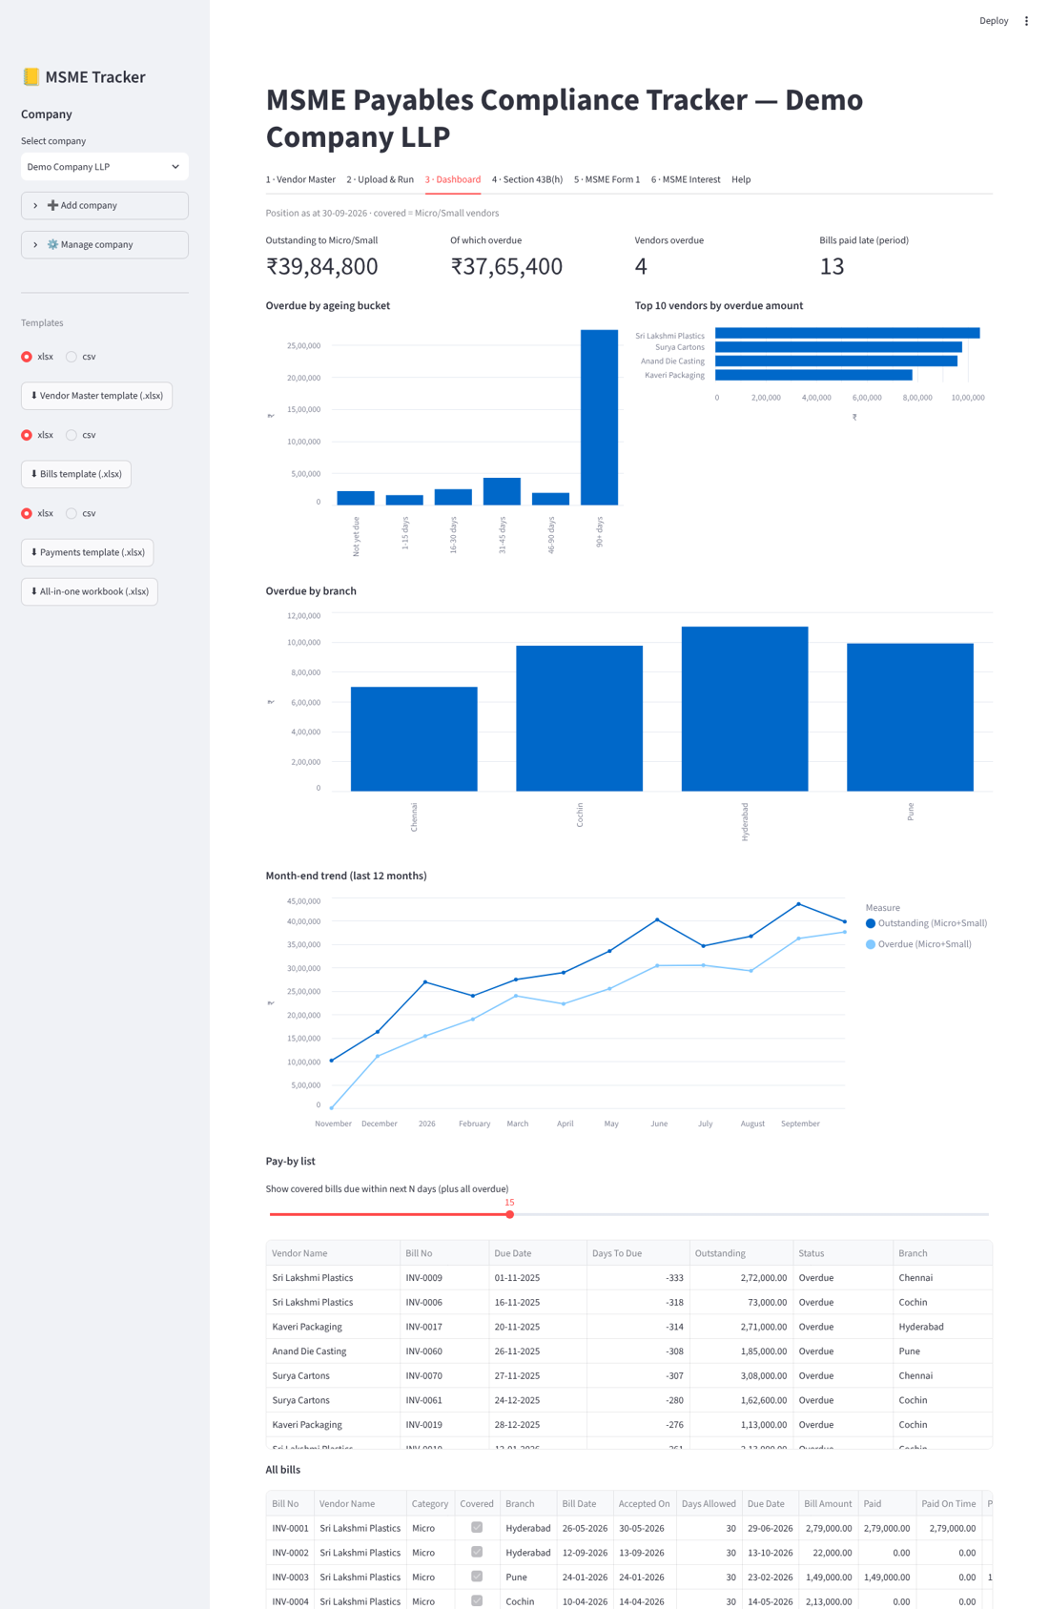
Figure 1 – Dashboard (demo data).
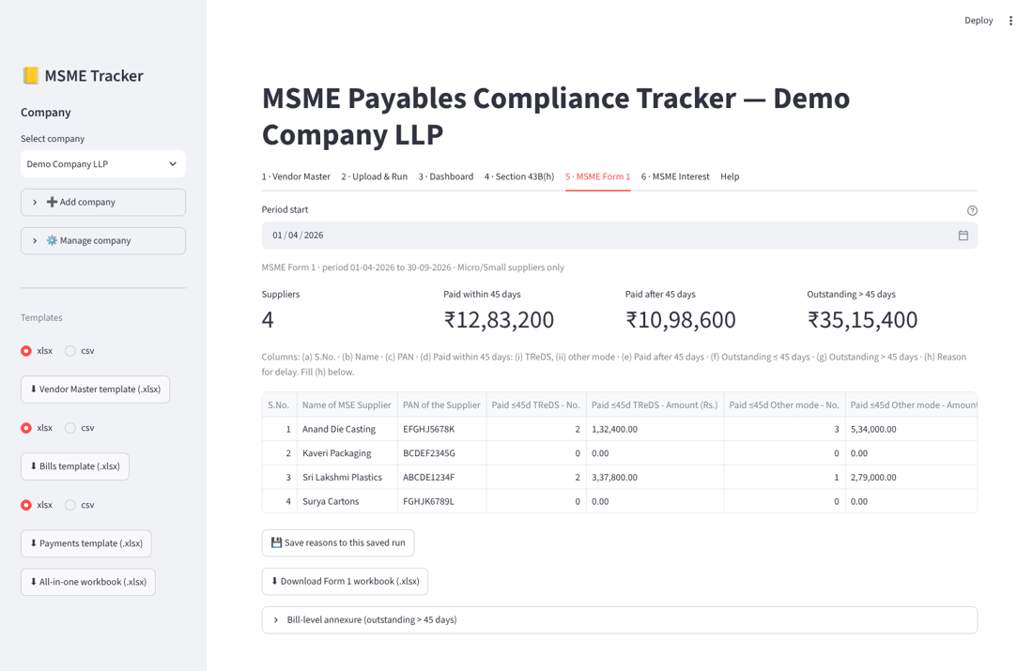
Figure 2 – MSME Form 1 in the prescribed layout.

7. Practical applications
- Finance teams: see which MSE bills to pay before they cross 45 days, and what to pay before 31 March to avoid disallowance.
- Statutory compliance: Form 1 workbook and interest statement for the half-yearly return and tax-audit reporting.
- CAs and group companies: one tool for many entities, each with its own master and saved runs, reading each one's own export.
- Vendor reconciliation: import a vendor's statement and compare with the books.

8. Limitations and running the app
- Unusual layouts may need correction in the review step; scanned PDFs need OCR. The importer has been tested on sample files, not yet on real statements.
- Keep the RBI Bank Rate table current, and confirm the Form 1 layout against the latest official format before filing.
- To run: install Python 3.10+, double-click Start_MSME_Tracker.bat (details in folder 4). Supports decision-making; not legal or tax advice.

